|  |  |
| --- | --- |
| Press Release  for Immediate Release | Contacts: Anna Lee  E-mail: [annalee@prlassbbq.food](mailto:annalee@prlassbbq.food)  Phone:+44(20)7777-7777 |

BBQ PR Lass Announces Plans to Open in Fall 2020

**Delicious BBQ Restaurant Will Be Satisfying the Londoner Crave, to bring the most delicious West Coast dishes from California to the city and surrounding areas. Pickup and delivery services are available from 10 am to 7 pm, and appointments and payments can be made through the App.**

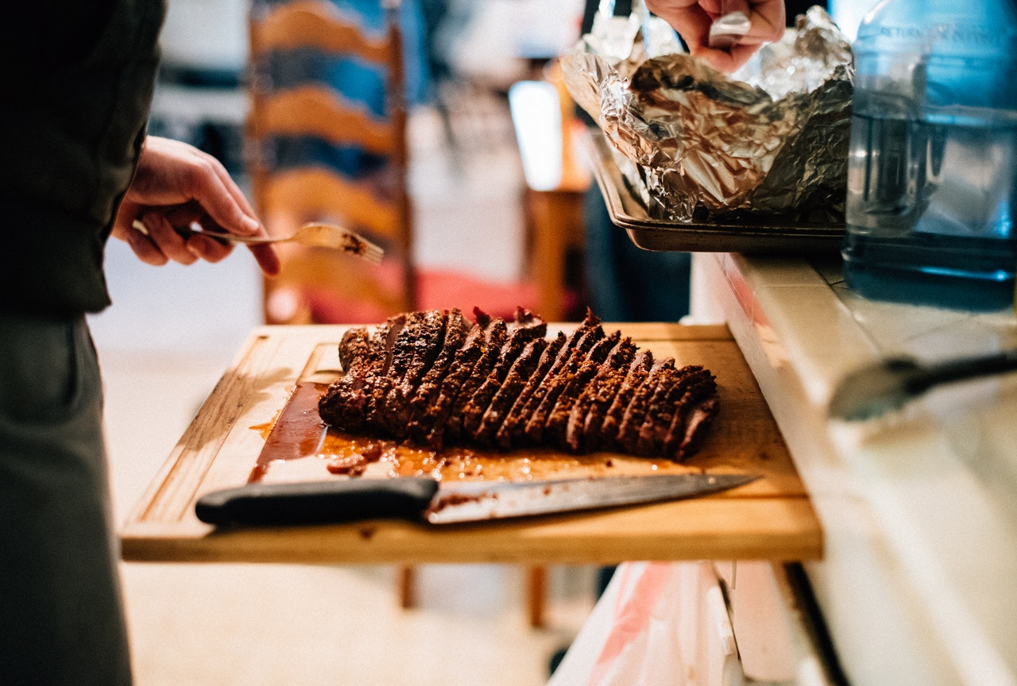

Classic American dishes, limited to 50 servings per day. (Photo: pexels.com)

(London, UK / May. 1, 2020) PR Lass Delicious Group, a leading global restaurant investment group, announced today that PR Lass BBQ, housed in one of the most iconic buildings in London, facing the prestigious Tower…

**About PR Lass Restaurant (PRLR)**

PRLR is the largest restaurant chain brand in the United States, operating worldwide network of more than 1,600 stores…

**Media Contacts**

Company:

Contacts:

E-mail:

Phone:

*注意：本新聞稿範例內容純屬虛構，如有雷同，實屬巧合！ (The stories, all names, characters, and incidents portrayed in this press release are fictitious.)*